**Aim:**

To demonstrate Infrastructure as a Service (IaaS) by creating a Resource Group and configuring a Virtual Machine with minimum CPU, RAM, and storage using Microsoft Azure Public Cloud.

**Procedure:**

1. Login to Azure Portal

* Open https://portal.azure.com.
* Sign in using your Azure account credentials.

2. Create a Resource Group

* Go to Resource groups → Click + Create.
* Enter details:
  + Resource group name: IaaS-Demo-RG
  + Region: East US (or any preferred region).
* Click Review + Create → Create.

3. Create a Virtual Machine inside the Resource Group

* Navigate to Virtual machines → + Create → Azure Virtual Machine.
* Fill in the following:
  + Subscription: Select active subscription.
  + Resource group: IaaS-Demo-RG.
  + VM name: IaaS-Demo-VM.
  + Region: Same as Resource Group.
  + Image: Ubuntu Server 22.04 LTS.
  + Size: Standard_B1s (1 vCPU, 1 GB RAM).
* Configure authentication:
  + Select Password and enter username/password.
* In Disks tab: Select Standard HDD (30 GB).
* In Networking tab: Keep default Virtual Network and Public IP.
* Click Review + Create → Create.

4. Verify Deployment

* Open the created Resource Group (IaaS-Demo-RG).
* Check that the Virtual Machine, Virtual Network, and Public IP are deployed successfully.

**OVERVIEW:**

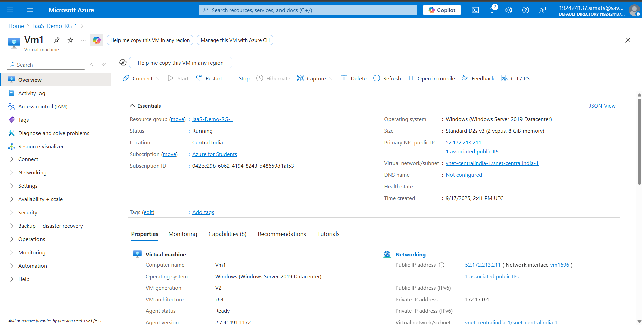

**OUTPUT:**

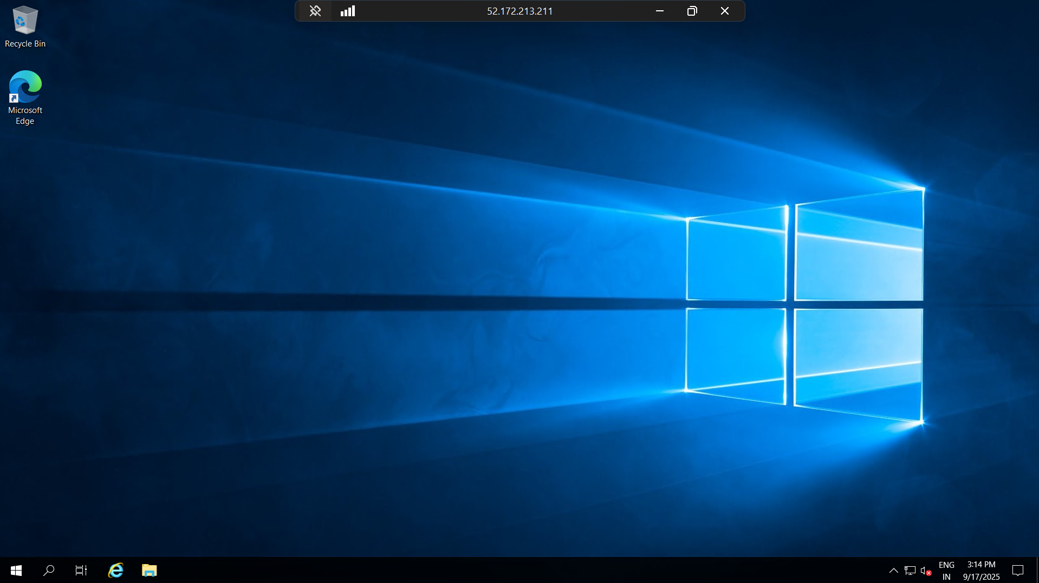

**Result:**

Infrastructure as a Service (IaaS) was successfully demonstrated by creating a Resource Group and deploying a Virtual Machine on Microsoft Azure with minimum configuration (1 vCPU, 1 GB RAM, 30 GB storage).